RFP Clarifications Memorandum

To: Vendors Responding to RFP Number 3760 for the Mississippi Department of Information Technology Services (ITS)

From: Craig P. Orgeron, CPM, Ph.D.

Date: September 20, 2024

Subject: Clarifications to Specifications

Contact Name: EPL Team

Contact Phone Number: 601-432-8000

Contact E-mail Address: epl.team@its.ms.gov

**RFP Number** **3760 is hereby amended as follows:**

1. **Section VI: RFP Questionnaire, Item 2.3.1 is being modified to add the registration link:**

Go to the EPL RFP Vendor Registration application located at the following address:

<https://www.ms.gov/its/epl_registration/>

1. **Section VI: RFP Questionnaire, Items 3.2 and 3.3 are deleted and replaced with the following:**

**3.2 Vendor Self-Certification:**

The State of Mississippi, in an effort to capture participation by minority Vendors, asks that any Vendor who can claim status as a Minority Business Enterprise or a Woman Business Enterprise submit substantiating documentation with their proposal.

This information is for tracking/reporting purposes only and will not be used in determining which Vendor will be chosen for a project.

For Mississippi Vendors, please direct any questions about minority certification in Mississippi to the Minority Business Enterprise Division of the Mississippi Development Authority by telephone at (601) 359-3448 or via email at [minority@mississippi.org](mailto:minority@mississippi.org). For information on the Mississippi Minority Business Registry, please follow the link below:

<https://mississippi.org/services/minority/>

1. **Section VI: RFP Questionnaire, Item 4 Certification of Authority to Sell is deleted and replaced with the following:**

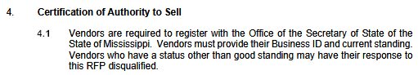

Business ID:

SoS Status:

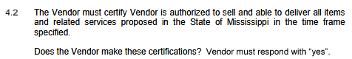

Vendor Response:

1. **Section VI: RFP Questionnaire, Item 11 Taxpayer Identification Number is deleted and replaced with the following:**

Vendor must include a W9 with their RFP response.

1. **Section VI: RFP Questionnaire, Item 12 is added as follows:**

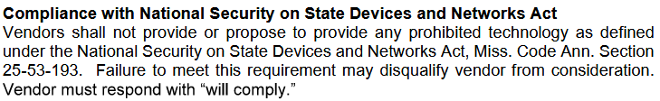

Vendor Response:

1. **Section VIII: IT Hardware Processes, Item 3 Procurement Project Schedule is deleted and replaced with the following:**

|  |  |
| --- | --- |
| **Task** | **Date** |
| **Initial Publishing** | |
| Open Initial Proposals | 3:00 p.m. Central Time on 6/12/2014 |
| IT Hardware EPL 3760 Publish Date (initial) | 7/1/2014 |
| **Ongoing Publishing** | |
| Acceptance and processing of new Reseller Groups. Responses will be processed by ITS as time permits. | New manufacturers may submit responses through the life of this EPL 3760. |
| Acceptance and processing of new sellers may be submitted by 3:00 p.m. Central Time at 6-month update periods. Proposals received after the 3:00 p.m. deadline will not be accepted for that update window.  Responses will be processed by ITS as time permits.  Existing sellers may update vendor fees at this time. | 3:00 p.m. on the first Tuesday of February and August through the life of this EPL 3760. |
| IT Hardware EPL 3760 Expiration Date | This EPL will remain in effect until terminated by ITS with thirty (30) calendar days prior notice provided to all vendors. |

1. **Section XI: Manufacturer Information Submission, Item 7 is modified to include the following additional required acknowledgement:**

_____ Yes, our company shall not provide or propose to provide any prohibited technology as defined under the National Security on State Devices and Networks Act, Miss. Code Ann. Section 25-53-193.

1. **The EPL Purchase Agreement has been updated as part of this amendment. The new version of the agreement is published on the RFP No. 3760 Download Page noted below:**

<https://www.its.ms.gov/procurement/RFPs_and_sole_sources_advertised>

Vendor must include in their proposal a response or acknowledgement, whichever is required, to items 2, 3, 4, 5 and 7.

If you have any questions concerning the information above or if we can be of further assistance, please contact EPL Team via email at epl.team@its.ms.gov.

cc: ITS Project File Number 48353